Name: Date: or words

The sound (or) is usually represented using the letters or when it comes in the middle of words, like in the words below.

Remember: Say the word aloud, then say each letter aloud as you write it e.g. 'torch, t ... o ... r ... c ... h'

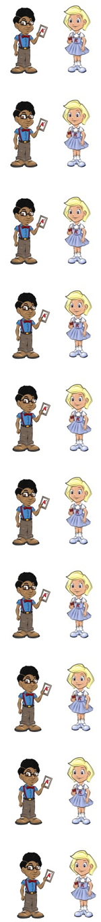
A torch is good to have in the dark.

Lord is another name for God.

You use a fork to eat with.

In a storm there is strong wind and rain.

Corn is a yellow plant that grows in fields.

A horn is made of brass.

A baby is a child that is newly born.

A pencil gets short after a while.

North points up on a compass face.

The king rode forth on his horse.

Now test yourself without looking at the words and check for yourself if you got them all right. Practice writing any words that you made mistakes on again.

© www.SaveTeachersSundays.com 2013
Name: Date: or words

The sound (or) is usually represented using the letters or when it comes in the middle of words, like in the words below.

Remember: Say the word aloud, then say each letter aloud as you write it e.g. 'torch, t ... o ... r ... c ... h'

Try to spell each word without looking at it.

A is good to have in the dark.

is another name for God.

You use a to eat with.

In a there is strong wind and rain.

is a yellow plant that grows in fields.

A is made of brass.

A baby is a child that is newly .

A pencil gets after a while.

points up on a compass face.

The king rode on his horse.

Now check for yourself if you got them all right. Practice writing any words that you made mistakes on again.

© www.SaveTeachersSundays.com 2013

